
NAME:

Teacher:

Multiple Choice Booklet Number:

A1/A2 CHEMISTRY - TEST 2 (2016) TIME: 50 Minutes

Stoichiometry and Rates of Chemical Reactions

PUT A CROSS (X) THROUGH THE CORRECT ANSWER.

1. | a | b | c | d |  | 8. | a | b | c | d
2. | a | b | c | d |  | 9. | a | b | c | d
3. | a | b | c | d |  | 10. | a | b | c | d
4. | a | b | c | d |  | 11. | a | b | c | d
5. | a | b | c | d |  | 12. | a | b | c | d
6. | a | b | c | d |  | 13. | a | b | c | d
7. | a | b | c | d |  | 14. | a | b | c | d

SECTION 1
/14
SECTION 2
/36
TOTAL
/50
PERCENTAGE

SECTION 2 – SHORT ANSWER - Answer all questions in the spaces provided.

- Write balanced chemical equations for the reactions described below, including state symbols in your equation. In the space underneath write what you would predict to observe during that reaction, including state, colour and odour (if applicable) for reactants and products in your answer.

  - Solid copper carbonate is added to a solution of hydrochloric acid to produce copper chloride, water and carbon dioxide gas.

Equation:

Observation:

[3 marks]

  - Cobalt chloride and potassium phosphate solutions are mixed to precipitate solid cobalt phosphate in a solution of potassium chloride

Equation:

Observation:

[3 marks]

- Which of the following two compounds has the greater percentage of copper by mass? Circle your response and show all working to justify your answer. [5 marks]

Cu(NO₃)₂ or Cu(CH₃COO)₂

- Hydrogen fluoride gas is produced in the following reaction.

H₂ (g) + F₂ (g) 2HF (g) ΔH = - 538 kJ

  - Sketch a labeled reaction profile (to scale on the y axis) for the chemical reaction above. The activation energy is 230kJ. [4 marks]

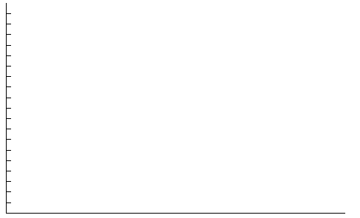

  - Is this an endothermic or exothermic reaction? [1 mark]

- If 2.00 g of hydrogen bromide and 14.0 g of water are mixed, what is the total number of hydrogen ATOMS present in the mixture? Show all working and give your answer to the appropriate number of significant figures. [4 marks]

- Nitric acid is manufactured by the Ostwald Process. In the first step, ammonia reacts with oxygen to produce nitric oxide in the presence of a catalyst. This reaction is carried out at a temperature of approximately 900ºC and at a pressure of 10 atmospheres.

4 NH₃ (g) + 5 O₂ (g) → 4 NO (g) + 6 H₂O (g) + heat
Use your understanding of reaction rates to explain the temperature and pressure conditions used in this step of the Ostwald Process. [5 marks]

- A mixture hydrogen and oxygen spontaneously catches fire if passed through a platinum gauze. Without the gauze no reaction occurs. State the role of the platinum gauze and explain its action using an energy profile diagram. [5 marks]

- Solid sodium hydroxide is added to a solution of ammonium sulfate to produce sodium sulfate, water and ammonia gas.
  - Write a balanced chemical equation for the reaction. [1 mark]

  - If 4.50 g of sodium hydroxide is added to excess ammonium sulfate solution, what mass of ammonia gas is produced? Make sure you show all working and give your answer to the appropriate number of significant figures. [5 marks]

END OF TEST – CHECK YOUR WORK

